How to setup Optimizer with Dynamic Time

Step 1: Create a list called “Months”

Step 2: Go to Configure tab, in Top Level Item type “All Months”, and select the Numbered List? Boolean

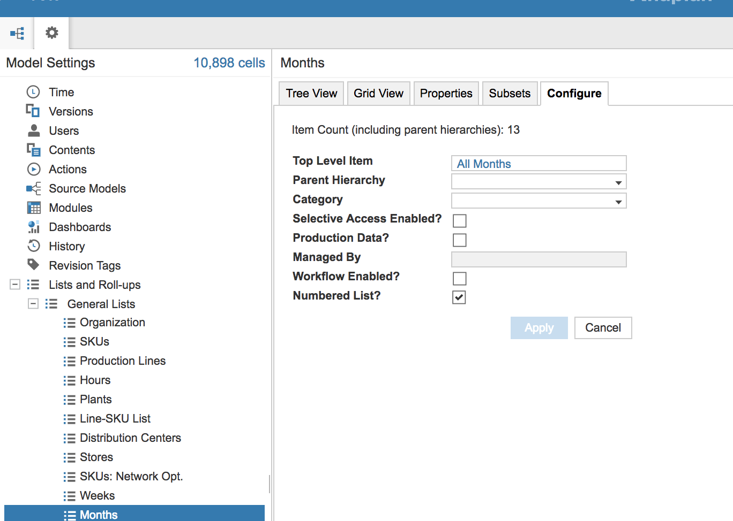

Step 3: Go the Properties tab and “Insert…” these properties, update the Format and add Formulas.

Property Name | Format | Formula
Display Name | Text, General | NAME(Month)
Month | Time Period, Month | PERIOD(CURRENTPERIODSTART()) + Cumulate Count - 1
Cumulate Count | Number | CUMULATE(Count, FALSE, Months)
Count | Number | 1

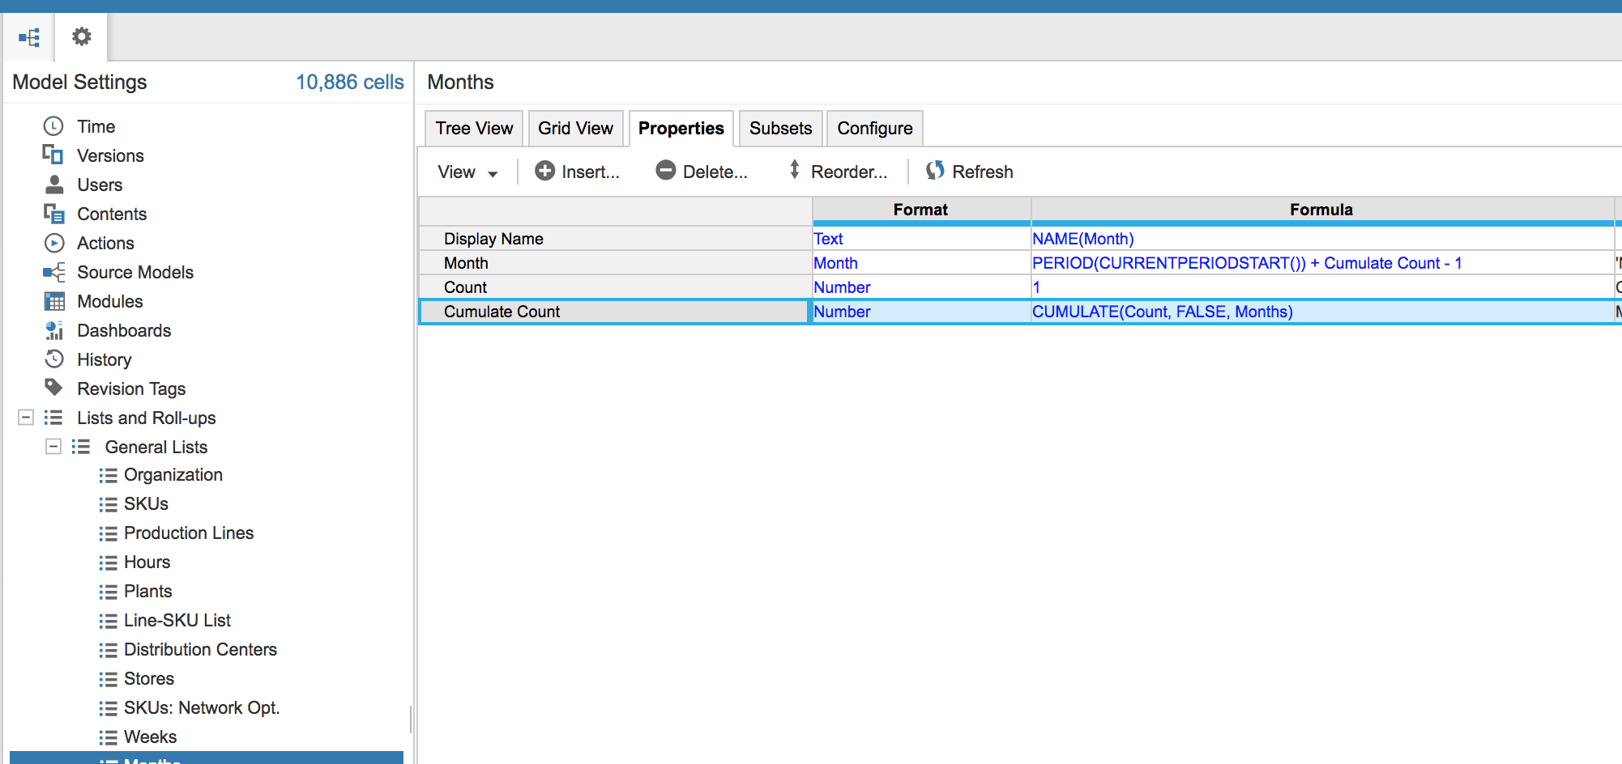

Step 4: Go to the General Lists section, and scroll to the right to the Display Name Property column, from the dropdown of your new “Months” list, select your “Display Name” property for the Display Name Property column.
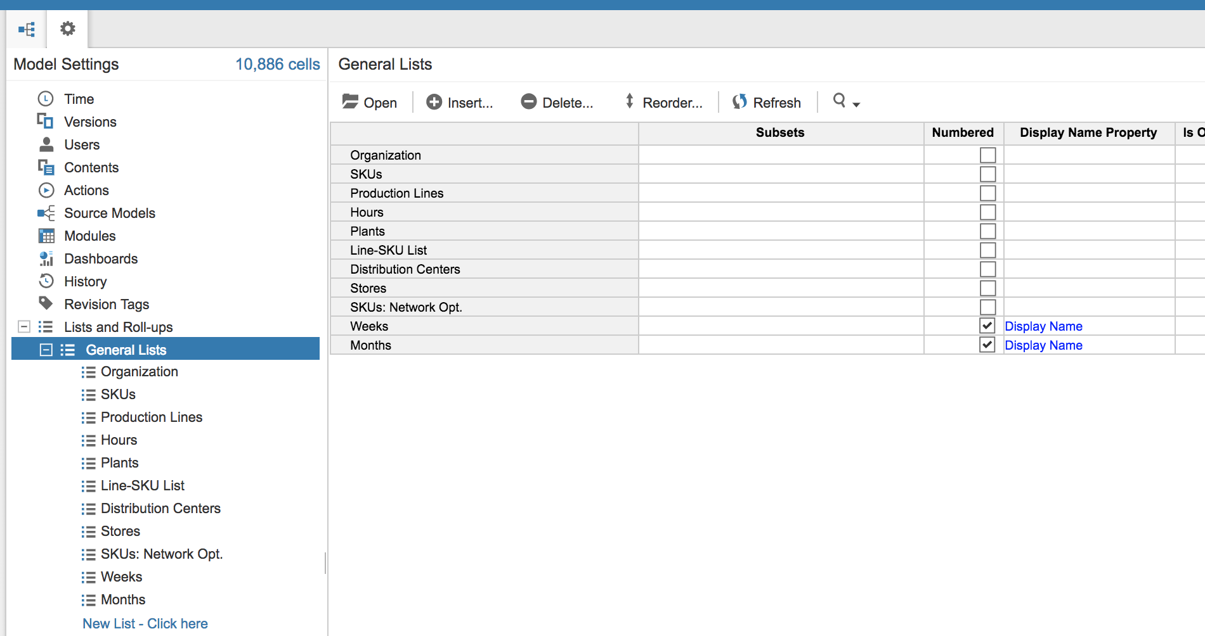

Step 5: Add list items to the Months list by selecting the “Insert…” tab and insert as many list items as you need for time periods.
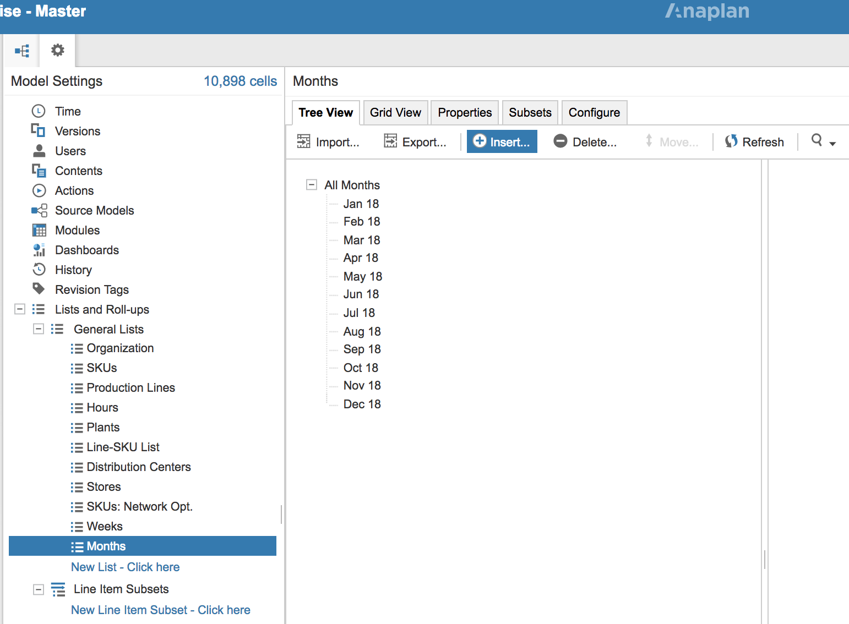
Step 6: Since the Month property is based on the Current Period setting in the Time dimension, future periods will require the Future Years in the “Time” tab to be something other than zero.

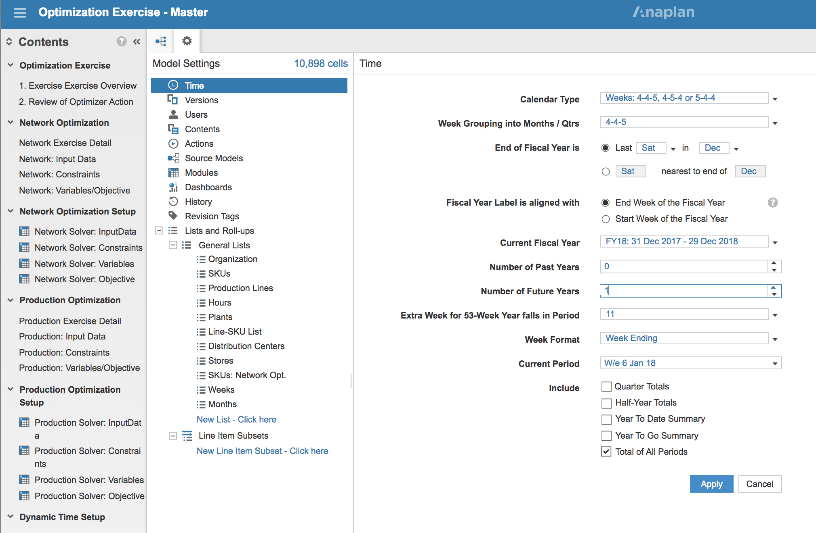

Step 7: Map dynamic time line items to real time line items by using a lookup on your real time period property of your dynamic time list. Formula should be: Real Time line item[LOOKUP: Months.Month]

All Constraint, Variable, and InputData line items that include time, should reference dynamic time and not real time.

